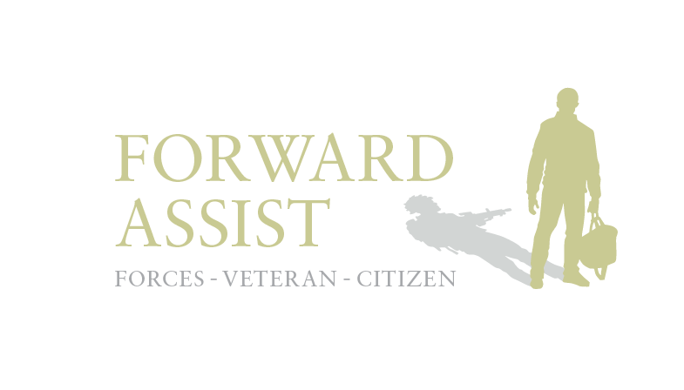

Female Veterans Group Research Trip

Washington DC

February
2017

Forward Assist is a North East of England based Charity that offer practical support and guidance to former service personnel of all ages as they physically & psychologically adapt to life as a civilian. Forward Assist promotes ‘community outreach & active engagement’ and involves former military personnel in projects that benefit the individual and the wider community. The Charity offers life coaching, employment advice, vocational skills training, including the acquisition of accredited qualifications and ‘life changing’ opportunities to promote physical and mental wellbeing. Forward Assist has three full time staff and 30 active volunteers, all of whom bring a wealth of experience to the team.
Forward Assist believe that by promoting ‘active citizenship’ former service personnel can be assisted in making the journey from ‘Soldier to Citizen’ The aim is to give veterans the opportunity to become ‘Community Champions’ and in doing so utilise their numerous transferrable skills. By facilitating the chance to ‘Do Good’ in the civilian community, via specific and well supervised ‘Community Benefit’ projects, Forward Assist has been able to assist veterans and other disadvantaged groups engage in activities that improve the mental and physical wellbeing of both parties. As a result, veterans gain the respect of the civilian community whilst also improving their own self-esteem, confidence, social networks and future employment prospects.
In 2011, Forward Assist Founder & CEO Tony Wright was awarded a Winston Churchill Memorial Trust Travelling Fellowship travelled to the USA to compare and contrast services available to military veterans with multiple complex needs in the UK and USA. On return Forward Assist set up a Veterans Exchange Programme to promote the sharing of best practice whilst enabling veterans from both countries the opportunity to experience international travel whilst acting as citizen ambassadors for their respective countries. Since 2013 Forward Assist has organised and facilitated four separate ‘Veteran Exchange Trips’ and the mutual benefit to both countries is evident given the sharing of information and practice. In 2016 Forward Assist were invited to travel to Washington DC to visit Fairfax Veterans Treatment Court and meet with Kayla Williams (Female Veterans Lead) at The Department of Veterans Affairs. The trip was kindly funded by Intu Metro Centre and Miles Macadam Construction and fundraising efforts by the Forward Assist Fundraising volunteers.
Forward Assist has for some time recognised that women veterans are very much a ‘hidden population’ and has campaigned for ‘Gender Specific’ mental health services to address this unmet need. As a highly innovative organisation, Forward Assist strives to identify and react to the needs of the veterans referred to our charity. Where there is an identified need we will create specific programmes to empower veterans and facilitate access to specialist support. The staff team was for many years’ male dominated. We employed Sarah Lattaway to address that imbalance and she has very successfully identified and engaged a core group of women veterans. Through direct consultation sessions with over sixty-five female veterans, which has involved women only group activities, one to one work, and general research on the topic, we very quickly ascertained that female veterans are disadvantaged by the lack of gender specific services available to them.

Through correspondence with our partner organisations in the USA we were able to reach out to our friends in Washington DC, who were able to link us with projects and individuals working with women veterans. We owe a massive debt of gratitude to Don Northcutt who facilitated the visit. In the spirit of our Veterans Exchange programme we wanted to take one of the female veterans accessing our service so that she could develop her own skills and share her own experiences. Lian Kirton is a former Army Dog Handler and served in Afghanistan. Since leaving the military she has set up her own Dog Walking company and is keen to set up a specialist assistance dog training programme for veterans suffering from Post-Traumatic Stress Disorder. In order to facilitate this, we arranged for her to meet a fellow dog trainer in the USA to share training techniques and improve her expertise in this area.

Forward Assist has for several years campaigned for Veterans Treatment Courts to be introduced into the UK Criminal Justice System. This exchange visit provided the opportunity to learn more about this subject and visit Fairfax Veterans Treatment Court.

Final Salute Inc.

On the first day of our visit we had the opportunity to meet with Final Salute Inc. which was founded in 2010 by Jas Boothe a USMC veteran and cancer survivor who became aware of the large number of homeless women veterans in the United States. The mission of Final Salute Inc. is to provide homeless women veterans with safe and suitable housing. Jas Boothe realized a need for an organization that was designed to meet and understand the unique needs of homeless women veterans and their children.

The Forward Assist team were delighted to meet with Founder Jas Boothe in person, Trustee Brian Drummond & Home Manager Mary to discuss the aims & objectives of the project.
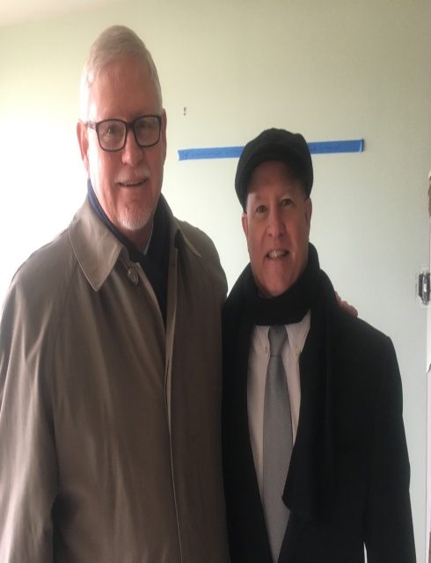
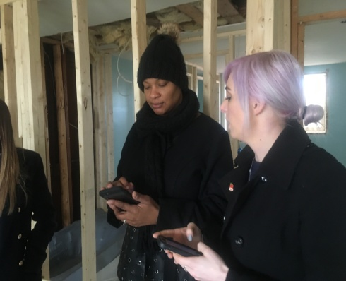
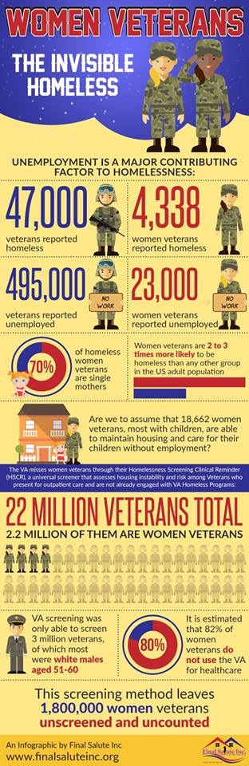
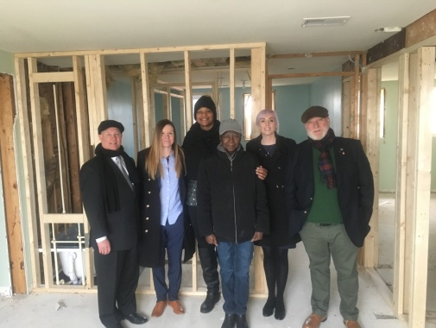
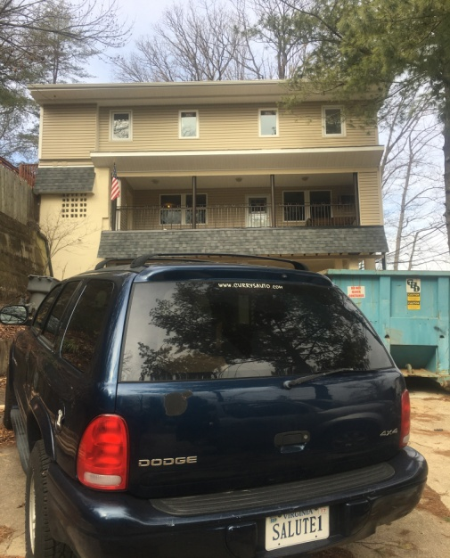

“There are no longer front lines in war; however, female veterans feel they are put at the end of line when seeking housing and other supportive services. In America, over 2,000,000 women have served with honour since the Revolutionary War. They have fulfilled their obligations to their country; we now need to support them during their time of need.”

Final Salute Inc. takes a three-pronged approach to addressing the issues associated with the homelessness of women Veterans: Awareness, Assistance & Aspiration.

- Awareness: Bringing attention to the American people that homelessness among women veterans is on the rise and their support needs are immediate.
- Assistance: Providing housing/supportive services to homeless women veterans and aiding in the prevention of homelessness for at-risk women veterans.
- Aspiration: Instilling in women veterans that their situations are temporary and their goals are still achievable.

Learning Outcomes:

- As far as we are aware the UK does not have a similar Housing Project which can house female military veterans and their children.
- In the UK no statutory organisation currently collects data on former service personnel. We would therefore find it difficult to find accurate data in regard to female veterans and homelessness or indeed any way to track their lives after military service.
- This project highlighted the need for gender specific housing support for female veterans and their children.
- Final Salute is the only organisation in the USA providing housing for homeless women veterans and their children.

Wreath Laying Ceremony at the Tomb of the Unknown Soldier
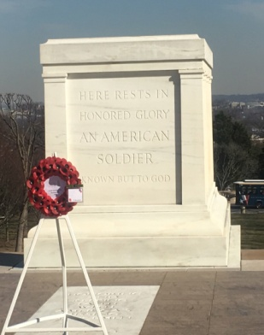
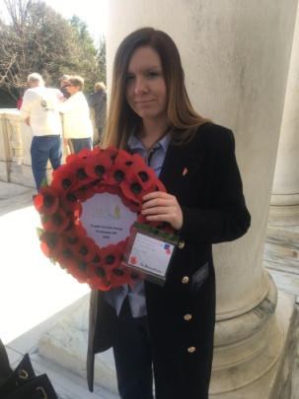
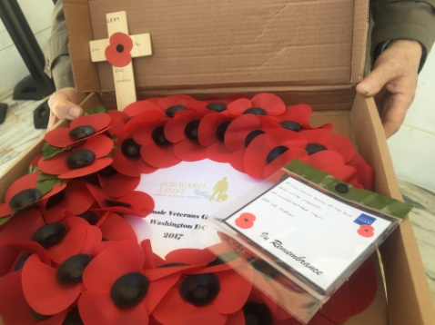

The Tomb of the Unknowns is a monument dedicated to American service members who have died without their remains being identified, based in the Arlington Cemetery. The Tomb Guards come from the 3rd U.S. Infantry Regiment "The Old Guard". Serving the U.S. since 1784, the Old Guard is the oldest active infantry unit in the military. They keep watch over the memorial every minute of every day, including when the cemetery is closed and in inclement weather.

Lian Kirton and Sarah Lattaway had the great honour of taking part in a wreath laying ceremony at the Tomb of the Unknowns in Arlington Cemetery. The Poppy Wreath was dedicated to the Women Veterans of Forward Assist. After being briefed by one of the soldiers and Sarah being briefed again by Lian on marching techniques, they marched with the ceremonial escort to lay the wreath and carried out a period of silence as a mark of respect.

Lian Kirton:

“It was the highest honour I have ever had and I was humbled to be asked to do it for Forward Assist.”

Sarah Lattaway:

“I was very proud to be able to assist Lian in laying the wreath and be able to show our respects to all of the UK & US service personnel lost on active service. It was an unforgettable experience and huge honour”

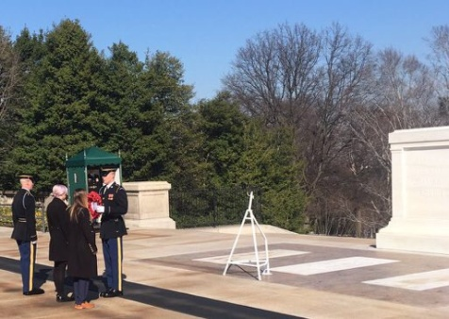

Semper K9 Service Dog Training Specialists

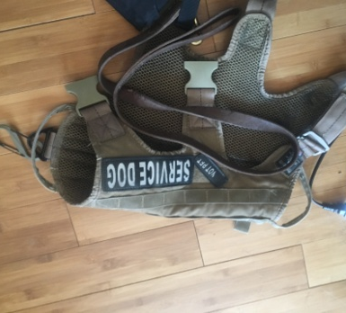
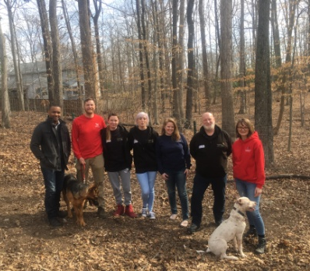
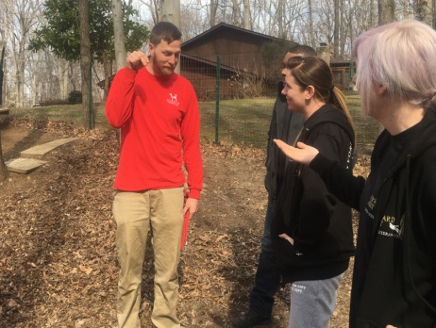

Semper K9’s mission is to enhance the quality of life for wounded, critically-ill and injured members of the U.S. Armed Forces and their families by providing them with assistance dogs. Using rescued and donated dogs they provide service dogs for psychiatric alert and mobility challenges free of charge to wounded service members.

According to the Veterans Administration, 834,463 veterans from OIF/OEF suffer from combat-related PTSD–that is 30%. Overall there are 10.6 million veterans living with combat-related PTSD in the United States of America.

It is estimated that in the USA a veteran commits suicide every 180 minutes. That is an average of 20 lives a day. It is also reported that every 11 seconds an animal is euthanized in the USA. Semper K9 is trying to help make a difference to those figures by rescuing dogs from shelters and training them to be service-assistance dogs for wounded service members and by doing so enhance the quality of life for service members and their families by helping them regain confidence and independence.
Forward Assist met with the Semper K9 team to discuss training techniques, their charitable status and how they determine the suitability of the dogs and veterans they assist. Lian was invited to contact Semper K9 to share ideas, training techniques and outcomes with the Semper K9 Team.
Learning Outcomes:

- There are specific training techniques and methodologies for training PTSD assistance dogs.
- The need to consider the training of volunteers to become foster carers for the dogs
- Develop vetting processes for dogs & veterans.
- Consideration needs to be given to an appropriate business structure to support the development of a not for profit business model in the UK.

Wreath Laying Ceremony at the Vietnam War Memorial Wall

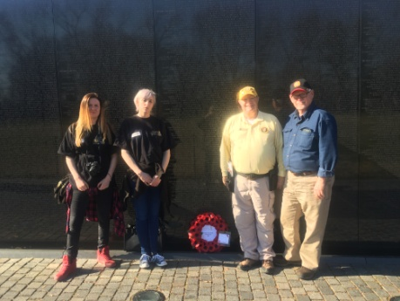
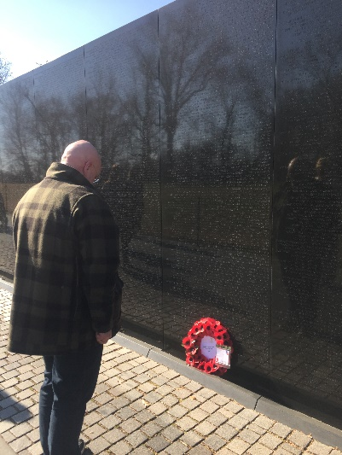
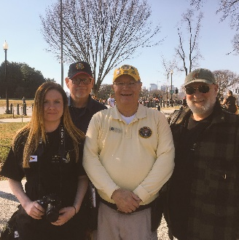

We were honoured to visit the Vietnam War Memorial Wall to pay our respects. The memorial includes the names of over 58,000 servicemen and women who gave their lives in service in the Vietnam Conflict. The memorial also includes "The Three Servicemen" statue and the Vietnam Women's Memorial.

We had the pleasure of a guided tour by Vietnam veteran & Purple Heart recipient Dan Kirby. Dan shared his personal story of combat in Vietnam and the history of the war memorial and the meaning behind each aspect of its design.

Tony had the honour of laying a poppy wreath dedicated to Sharon Lane, of the Army Nurse Corps who was the only American woman killed by enemy action in Vietnam.

“I grew up watching news footage of the Vietnam War and laying a wreath at the Vietnam Memorial Wall was an honour and a privilege I will never forget”
Tony Wright

Fair Winds Craft Beer Brewery
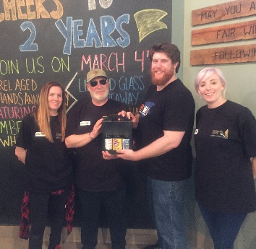
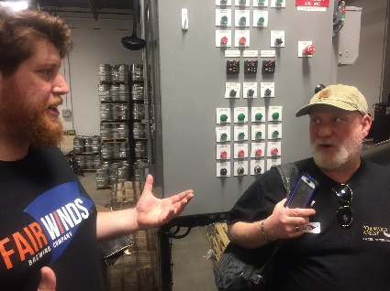
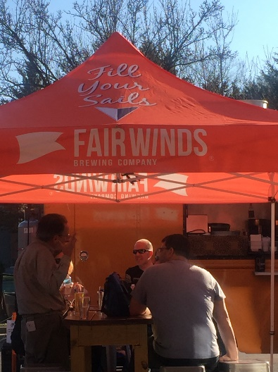

Forward Assist work in partnership with Salute Brewery a small ‘not for profit’ micro-brewery based in North Shields on the North East Coast of England. Our host Don Northcutt was able to facilitate a visit to Fair Winds Brewery to ‘trade’ craft beers and build links between our veteran owned breweries. Fair Winds company brewery and tasting room is based in Lorton, Virginia and caters to flavour-conscious consumers who want to drink exceptional, locally produced craft beers in their favourite restaurants or pubs, without having to make a separate trip to a brewpub. They also boast an expansive taproom and mobile BBQ Food Truck.

Fair Winds was founded by Casey Jones a former US Coastguard & the Sales Manager served in the US Navy. This Veteran owned business is very keen on giving back and donates a certain amount of their profit to a variety of different military charities.

Learning Outcomes:

- Selling beer in cans rather than bottles is more cost effective
- Marketing focuses on the beer rather than their military backgrounds & charity giving
- Bar attached to the brewery is a huge selling point allowing customers to taste the beer on site and able to see the brewing taking place.
- The UK has a lot to learn from the way ‘Veteran Owned Businesses’ in the US operate and support one another through a network dedicated to former service personnel and gives practical assistance/advice and/or trading opportunities with one another when possible. This model should be developed in the UK through Enterprise Agencies and stronger links with Veterans Charities and the MOD.

Boulder Crest Retreat

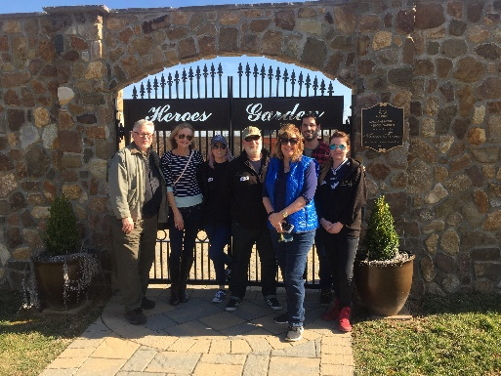
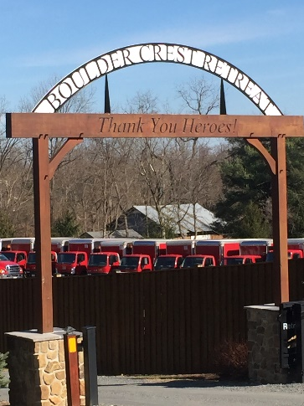

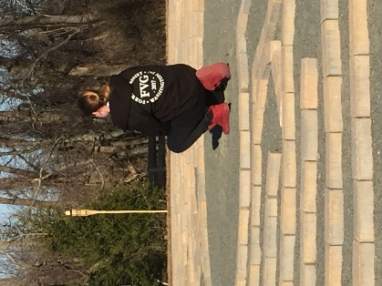

Boulder Crest Retreat is the nation's first privately-funded rural wellness centre dedicated exclusively to their nation's combat veterans and their families. They are committed to improving the physical, emotional, spiritual and economic wellbeing of this remarkable community of heroes, and ensuring they have the opportunity to succeed in their new mission - a life full of passion, purpose and service.

It is their view that it is veterans who, forged on an anvil of adversity, possess rare skills and abilities that are seldom seen and badly needed in the USA. It is veterans who possess a unique sense of strength, perseverance, selflessness, sacrifice, service, integrity, honour, and perhaps, most importantly, the ability to simply get things done.

The 2.7 million men and women who served in Iraq, Afghanistan and other locations have the experience, the ability and the potential to be the nation’s Next Greatest Generation.

In order to unlock that potential, Boulder Crest Retreat provide combat veterans and their families with a free, safe and sacred place to rest, reconnect and recharge through the PATH Programme - Progressive and Alternative Training for Healing.

Learning Outcomes:

- The focus on Post Traumatic Growth rather the Post Traumatic Stress facilitates a positive psychological change that embraces adversity in order to rise to a higher level of functioning.
- Shared agreement that civilian staff bring a wealth of experience and life skills to the staff team.
- The use of holistic therapies – that assist with reducing stress and anxiety
- An emphasis on holistic approaches to transition that echo Forward Assists intervention model.

Capitol Hill: House of Representatives - Guests of Congressman Gerry Connolly

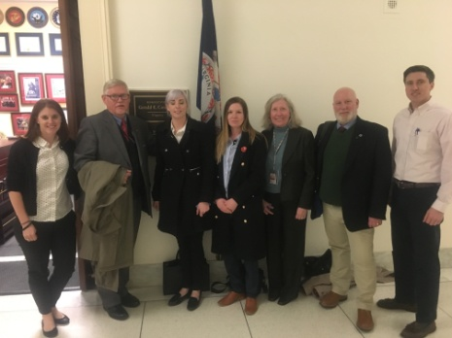
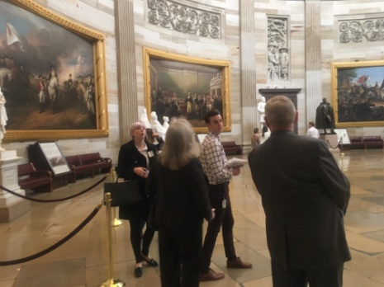

The United States House of Representatives is the lower chamber of the United States Congress which, along with the Senate, composes the legislature of the United States. The composition and powers of the House are established by Article One of the United States Constitution.

Forward Assist had the pleasure of meeting Sharon Stark, District Director for Democrat Congressman Gerald Connelly and support staff, to discuss the need for gender specific support for female veterans in the UK and ways in which we could share expertise between our two countries.

We were also given the opportunity to have a guided tour of the US Capitol Building with Sharon as our guide. We were delighted to be told that Sharon and her team are keen to support the UK in any way they can to assist in the development of a gender specific service for female veterans. Sharon offered to facilitate further visits and if needed come to the UK to talk about sharing best practice in this area.

Department of Veterans Affairs
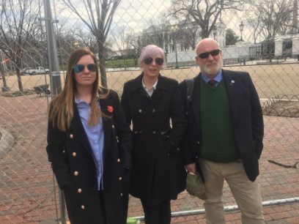
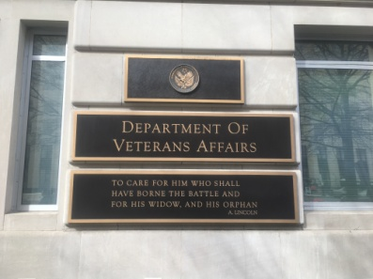
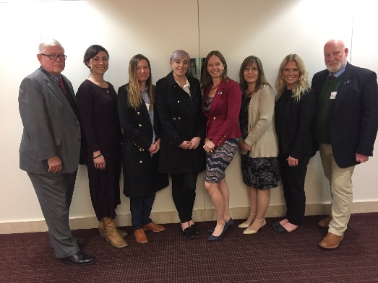

The United States Department of Veterans Affairs is a government-run military veteran benefit system with Cabinet-level status. While veteran’s benefits have been provided since the Revolutionary War, the Veterans Administration itself was founded in 1930, and became the cabinet-level Department of Veterans Affairs in 1989.

We met with Director of women’s services Kayla Williams, Legislative Associate Kayda Keleher and Nancy Glowacki to discuss how they assist female veterans on transition. Currently 15% of the American Military are women with the number increasing.

Whilst the VA have a full department dedicated to female veterans, it became clear that they are still developing women veteran services and are actively assessing need through research. Forward Assist agreed to share our UK research findings with the Department of Veterans Affairs to improve services and practice in both the UK and USA.

Learning Outcomes

- Military sexual trauma (MST) is a large issue within the American Military. More research needs to be carried out to see if we have similar problem in the UK.
- The Dept. of Veterans Affairs track veterans after service and are able to send out questionnaires as part of ongoing lifelong research and support.
- Female veterans in the US military have broadly similar issues as UK female veterans in that the wider community do not seem to recognise women’s military service in the same way as men and are treated differently to their male counterparts.
- The VA is Government funded which gives them a very large budget to support Veterans with medical Services, benefits, research and lifelong educational opportunities.
- The VA’s ability to track women veterans gives them access to a wide range of statistical data – something the UK are unable to do at this juncture.
- The four major issues for American female veterans, according to the VA, are healthcare, outreach and homelessness. Whilst healthcare and homelessness may differ to that of the UK it is clear that the issue of identifying women veterans in need & outreach is an issue for women transitioning regardless of which country they live in. Further research is needed in the UK to track and consult with female veterans after service.

Department of Veterans Services
Fairfax Washington DC

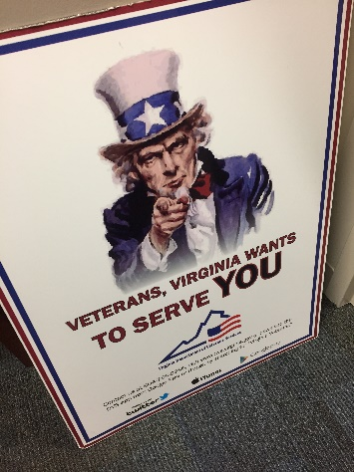
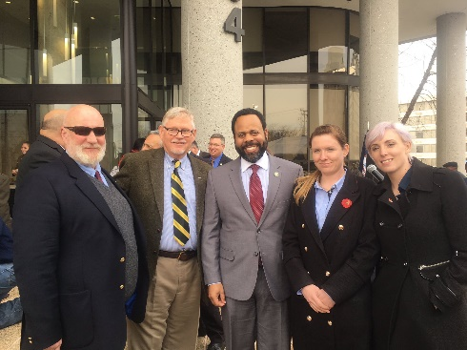
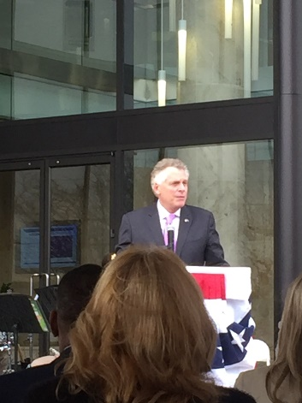

The Virginia Department of Veterans Services (DVS) connects Virginia’s veterans and their families to federal and state benefits, support, quality care, and provides the recognition they have earned. They offer a wide variety of services under one roof including, a Veterans Education Training and Employment (VETE) programme which ensures that every Veteran or eligible person has a fair opportunity to reach his or her fullest potential.
The Virginia Veteran and Family Support (VVFS) (formerly known as the Virginia Wounded Warrior Program) was established in 2008 in response to the growing need to improve and expand services to the nation’s veterans and their family members coping with the impact of deployment, military service, post-traumatic stress, operational stress and/or traumatic brain injury.
The Veterans Services Foundation is an independent state agency that supports veterans and their families through the Virginia Department of Veterans Services’ (DVS) programs and services. The Virginia Veterans Services Foundation accepts donations to support critical programs and services for Virginia’s veterans and their families that are not covered by state or federal funds.

Forward Assist had the pleasure of attending the opening of the Fairfax offices and chat with a wide variety of their staffing team including George Matthews a Veterans Resource Specialist and Fred Pickering - Certified Peer Recovery Specialist.

Learning Outcomes:

- Having a number of different services operating under one roof is very beneficial and can assist in veterans getting the help they need
- Outreach work and a holistic approach to delivery is crucial to support veterans going through transition
- There will always be a need for an alternative to State & Government funded Departments and/or Projects, as National Organisations may struggle to provide the “on the ground” coverage that a plethora of smaller organisations based in different geographical locations are able to do.

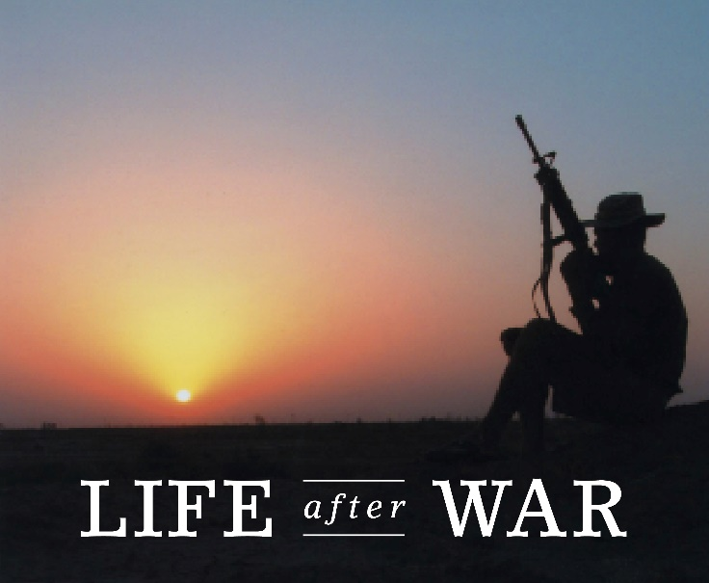

Fairfax Veterans Treatment Court

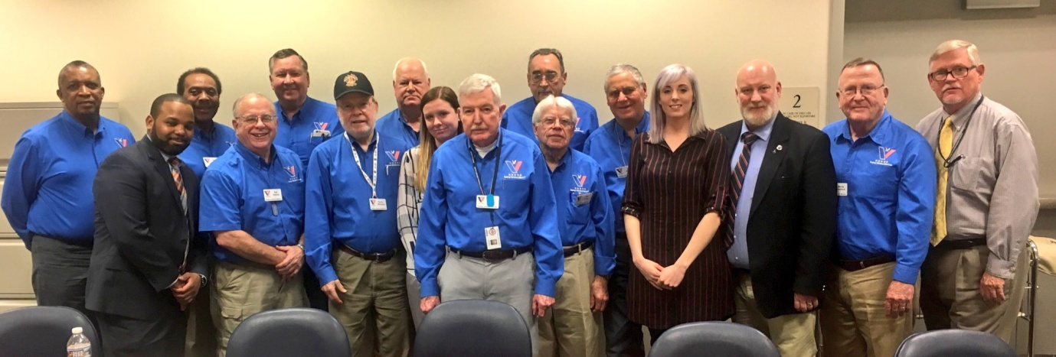

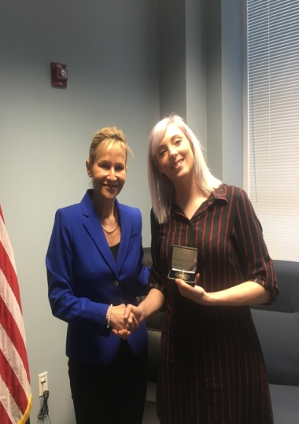
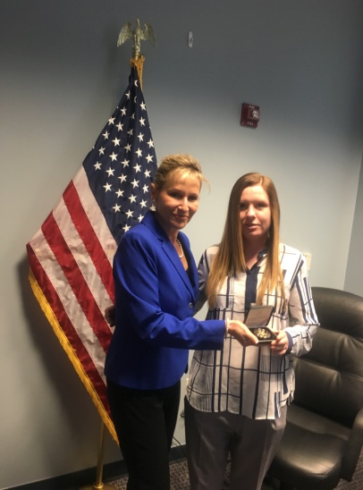
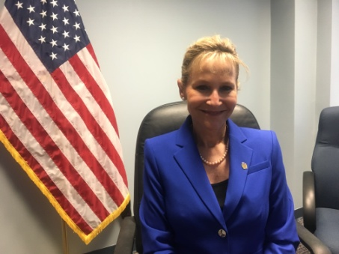

The Fairfax County Veterans Treatment Docket (VTD) is a court-supervised, comprehensive treatment program. All participants have been determined to have substance use issues and/or have other diagnosed mental health conditions. Participants in this program undergo supervision - i.e. regular court appearances before the Veterans Treatment Docket Judge and treatment which includes drug testing, individual counselling and group counselling provided by the Department of Veterans Affairs or Fairfax County facilities.

Participants are also expected to meet with a Veteran Mentor, obtain and maintain employment or involvement in vocational or educational programs, and actively participate in self-help meetings (e.g., Narcotics Anonymous, Alcoholics Anonymous) and/or counselling programs. The length of the Veterans Treatment Docket program is determined by each participant’s progress but will generally be 18-24 months in length, and will typically consist of three phases (Orientation/Stabilization, Ongoing Treatment, and Transition/Graduation).

Forward Assist had the opportunity to meet with all of the veteran’s mentors and attend court where the veterans met with the judges to discuss their progress.

Whilst at the courts the Forward Assist team were honoured and humbled to receive the Sheriff’s Office Coin presented by Sheriff Stacey Kincaid ‘in appreciation for the guidance and life changing projects and opportunities we provide to veterans adjusting to civilian life.’

Learning Outcomes:

- The Veterans Treatment Court model could and should be adapted and implemented in the UK Criminal Justice System.
- The use of Veteran ‘Peer Mentors’ to support veterans involved in the Criminal Justice System should be replicated in the UK Criminal Justice System.
- Respect and peer led encouragement goes a long way in assisting a veteran’s recovery journey.
- A Court directed veteran specific and monitored and directed ‘care plan’ would make a huge difference to the current hap hazard support services made available to veterans currently involved in the UK Criminal Justice System.

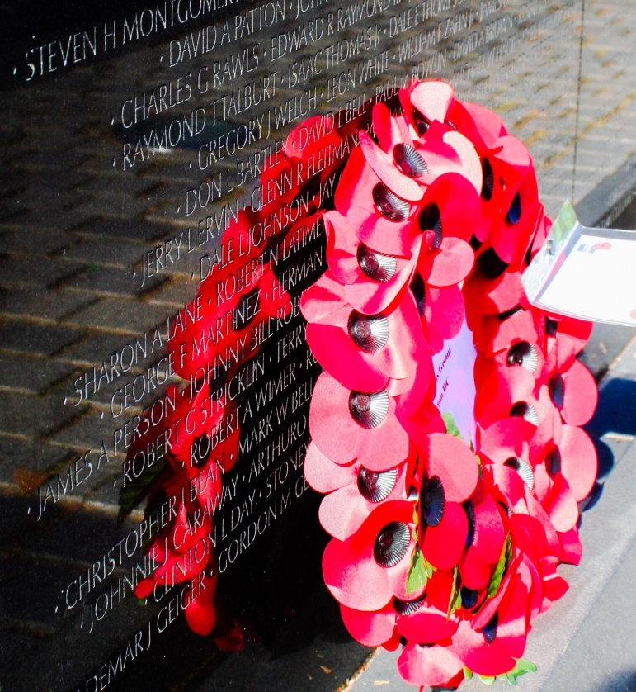
Final Comments

Lian Kirton

‘I had a truly eye opening and moving experience, learning that support is out there for veterans but also the struggle they still go through, despite there being properly funded departments. It was amazing to see people willing to give their all just to help fellow veterans and how their passion to do so is ‘waking people up’ to the issues female veterans are facing when leaving the forces.

I've enjoyed every bit of the trip and learned so much about myself, my limitations and how I can move forward. One particular achievement for me was being able to walk into the shopping mall by myself when I needed something; I think the huge support that was given to me helped with this. Normally I would just hide away in my hotel room until I was around people I trusted. In the past I've even skipped meals because of this so this was huge step forward for me and I wanted to achieve, as I felt empowered by what was happening around me.

As a veteran I went through the mill with emotions, I was almost embarrassed to discuss my combat experiences but being in America I learned it's ok to be proud and use your experiences to help others around you - there's no medal collection competition, everyone has a story to share.

I was taken back whenever anyone would shake my hand and thank me for my service.

The veteran’s courts really struck something within me... it was such an emotional experience to hear the stories of veterans that had lost their way in life. I was able to relate to some of the stories. Most importantly though was seeing the team of people who genuinely care, all the way up to the Judge who was trying to make the best for each individual veteran.

Meeting the head trainer at SemperK9 was brilliant; Chris really got my head in gear as to how future ideas can come together. I know I now have a fellow trainer to consult with should I have any more questions.

Washington has been totally inspiring and emotional. The generosity of people has been unbelievable; I have come back ready to get involved and to make a difference. I can turn my weaknesses into strengths and, most of all I know with the support of Forward Assist I can break down barriers, personal ones and/or help others.’

Sarah Lattaway

“I was honoured to be given the opportunity to represent Forward Assist in Washington DC and to have the chance to see how their Veterans services are run over there. It was also a great networking opportunity.

The trip was life changing for myself, feeding my passion for veteran’s services even more than I thought possible. It was inspiring to see how many people respect and want to help their veterans without ego and the need for self-validation, it’s all about the veterans – Exactly what our ethos is at Forward Assist.

Meeting with such a wide variety of organisations gave us the chance to look at different ways we can develop Forward Assist as a charity and most importantly how we can develop our female veterans support service. This trip was a truly remarkable and unforgettable trip.”

Tony Wright

“Simply...Outstanding”

“The willingness with which our young people are likely to serve in any war, no matter how justified, shall be directly proportional to how they perceive the Veterans of earlier wars were treated and appreciated by their nation”.
George Washington

We would like to take this opportunity to offer special thanks to our sponsors Intu Metro Centre, Miles Macadam & our extraordinary team of volunteer fundraisers. This trip would not have been possible without the fantastic hospitality shown by Don & Anna Northcutt, Hyatt Hotels & Geoff Mason from Macerich at Tysons Corner. Indeed, everyone we met in the USA took the time to make this a trip to remember. Thank you.

In summary, the far reaching impact of this research trip should not be underestimated as on return from the USA Team Forward Assist were invited to take part in an All Party Parliamentary Group led by Emma Lewell–Buck MP in the Houses of Parliament on 14th March 2017. We were able to share our findings from our research trip to Washington DC but more importantly facilitate dialog between socially isolated women veterans with academics from Derby University, Dr Ruth Allen CEO British Association of Social Workers, Justine Baynes SSAFA, Anne-Marie Trevelyan MP and Dame Vera Baird and others.
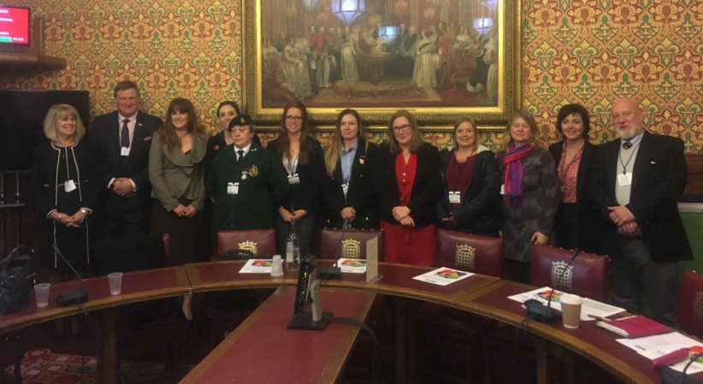

Following on from this meeting Anne-Marie Trevelyan MP for Berwick and Patron of Forward Assist raised the issue at Prime Ministers Question Time on 21st March 2017. Prime Minister Theresa May not only commended the work of Forward Assist but suggested Anne- Marie Trevelyan facilitates a meeting with Michael Fallon Secretary of State for Defence, to explore how to best to address this disadvantage.

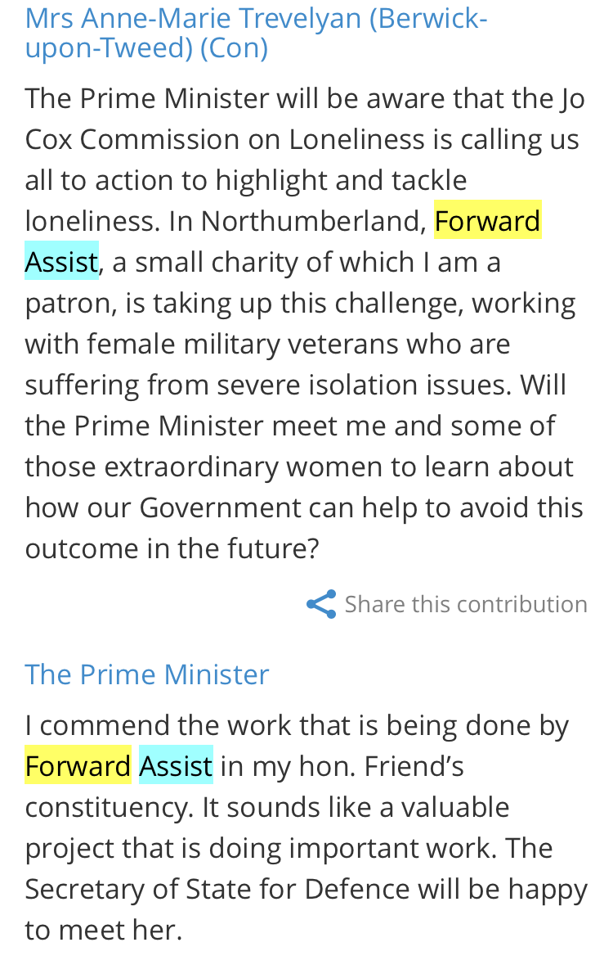

Expenditure

Intu Metro Centre £4000.00- Hotels & Flights
Miles Macadam £600.00: Sponsored Lian Kirton - Female Veteran Travel Costs.
Forward Assist Volunteer Fundraisers- £1000.00
Meals & Sundry Expenses

Contact Details

Forward Assist
C/o The John Willie Sams Centre
Market Street
Dudley
Cramlington
Northumberland

NE23 7HS
Tel: 0191 2504877
Email: admin@forward-assist.co.uk
www.forward-assist.com

